ADI

VITAL SIGNS MONITORING (VSM) WATCH IV USERS GUIDE

Revision List

Table 1: Revision List

|  |  |  |
| --- | --- | --- |
| **Revision** | **Date** | **Description** |
| 0.1 | 27-July-2020 | Initial Draft |
| 0.2 | 4-Aug-2020 | Updated sections for DCB commands and removed irrelevant sections |
| 0.3 | 10-Oct-2020 | Updated the latest release features |
| 0.4 | 23-Nov-2020 | Updated the UDP structures for all the streams |
| 0.5 | 09-Dec-2020 | Updated the Multiview features |
| 0.6 | 10-Feb-2021 | Updated the Low Touch features |
| 0.7 | 12-Mar-2021 | Updated the HR support in the usecases |

Copyright, Disclaimer Statements

Copyright Information

Copyright (c) 2021 Analog Devices, Inc. All Rights Reserved. This software is proprietary and confidential to Analog Devices, Inc. and its licensors. This document may not be reproduced in any form without prior, express written consent from Analog Devices, Inc.

Disclaimer

Analog Devices, Inc. reserves the right to change this product without prior notice. Information furnished by Analog Devices is believed to be accurate and reliable. However, no responsibility is assumed by Analog Devices for its use; nor for any infringement of patents or other rights of third parties which may result from its use. No license is granted by implication or otherwise under the patent rights of Analog Devices, Inc.

Table of Contents

Revision List 2

Copyright, Disclaimer Statements 3

Table of Contents 4

List of Figures 6

List of Tables 7

List of Code Snippets 7

1 Introduction 8

1.1 Purpose 8

2 Hardware 9

2.1 Watch Connections 9

2.1.1 Boot mode Buttons 9

2.1.2 USB Connections 9

2.1.3 Nordic BLE Dongle Setup 10

3 Quick Start Guide 12

3.1 Updating Firmware 12

3.2 Connecting to the Watch 13

3.2.1 Connecting using USB (Cradle) 13

3.2.2 Connecting using BLE 15

3.3 Basic Wavetool View Controls 16

3.4 Multiview Application 17

3.4.1 Running Use-cases for the Multiview 17

3.4.2 Multiview Usecases 18

3.4.2.1 Usecase1 - ADPD High Performance 18

3.4.2.2 Usecase2 - ADPD + EDA 19

3.4.2.3 Usecase3 - ADPD + ECG 20

3.4.2.4 Usecase4 - PPG + ECG (High Performance) 21

3.4.2.5 Usecase5 - ADPD Multislot 21

3.4.3 Configuring Use-cases for the Multiview 22

3.4.4 Multiview Controls 24

3.4.4.1 DCB Access 24

3.4.4.2 Low Touch Configuration 25

3.4.5 Configuring Settings for the Applications in Multiview 31

3.5 AWT Extension Modules 31

3.6 Logging Data in Local Files 36

3.7 NAND Flash Logging 38

3.7.1 Logging in NAND Flash 38

3.7.2 Retrieving data from NAND Flash 40

4 FAQs 41

4.1 What happens when a connection fails? 41

4.2 Can I stream data when NAND flash logging is enabled? 42

4.3 What are the restrictions of streaming data using BLE? 42

4.4 How do I change the Filter settings in JSON file? 42

4.5 How to flash firmware when firmware update gives the warning “Target not found”? 43

Terminology 45

References 46

List of Figures

Figure 1: ADI VSM Study Watch Framework 8

Figure 2: ADI VSM Study Watch with charging cradle 9

Figure 3: Navigate and Action Buttons 9

Figure 4: USB Connection 10

Figure 5: nRF Connect App 10

Figure 6: Nordic BLE Dongle 10

Figure 7: Connecting the BLE Dongle in Boot mode 11

Figure 8: Firmware Update Completion 11

Figure 9: Wavetool Software Main Window 12

Figure 10 : Firmware Update Window in Wavetool 13

Figure 11: USB Cable connection to the Watch 13

Figure 12 : Device Connected 14

Figure 13 : Application Selection 14

Figure 14 : BLE Connection 15

Figure 15 : Multiview 17

Figure 16: Multiview ADPD + ADXL 18

Figure 17 : Multiview ADPD + EDA 19

Figure 18 : Multiview ADPD + ECG 20

Figure 19 : Multiview PPG + ECG 21

Figure 20 : Slot selection 21

Figure 21 : Multiview ADPD multislot 22

Figure 22: Multiview Use-case Definition File 23

Figure 23 : DCB Access 24

Figure 24 : DCB in Multiview 25

Figure 25 : Low Touch Tuning Selection 25

Figure 26 : Low Touch Tuning FW Lcfg 26

Figure 27 : Low Touch Tuning Wrist detect DCB 27

Figure 28 : Low Touch Config 28

Figure 29 : Low Touch Config Success 28

Figure 30 : Low touch started 29

Figure 31 : Low touch stopped 29

Figure 32 : Low touch mode 30

Figure 33 : Watch normal mode 30

Figure 34: Multi-view Configuration 31

Figure 35: UDP Settings for Data Transfer 35

Figure 36 : Multiview UDP enable 35

Figure 37 : Open Log 36

Figure 38 : Logging Settings 36

Figure 39 : Log Folder 36

Figure 40 : Log Files 36

Figure 41 : CSV Folder 37

Figure 42 : CSV Data 37

Figure 43 : JSON Folder 38

Figure 44 : JSON Data 38

Figure 45: Logging Settings in Main window 39

Figure 46: NAND Flash Logging Settings 39

Figure 47: Download Log from NAND Flash 40

Figure 48 : Connection Failed 41

Figure 49 : BLE Connection Failure 41

Figure 50 : Watch COM port properties 43

Figure 51 : Update driver 43

Figure 52 : Browse driver software 44

Figure 53 : Pick the available driver on computer 44

Figure 54 : Install the driver 45

List of Tables

Table 1: Revision List 2

Table 2: Terminology 45

Table 3: References 46

List of Code Snippets

**No table of figures entries found.**

# Introduction

The ADI VSM Study Watch is a product designed to showcase the capabilities of ADI’s sensors for measuring vital signs.

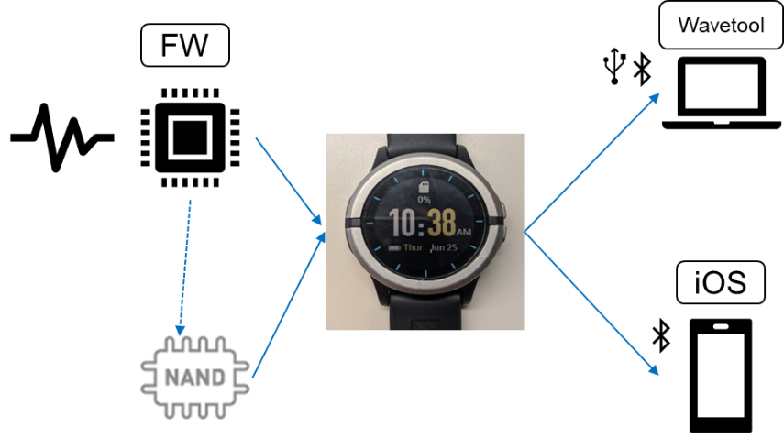

Figure 1: ADI VSM Study Watch Framework

## Purpose

The purpose of this document is to explain the steps on how to connect and run the ADI VSM Study Watch to analyze VSM application data using ADI’s Wavetool Software.

# Hardware

Please refer to the to the ADI VSM Study Watch datasheet for detailed hardware information.

The watch comes with a charging cradle – with micro USB charging capability

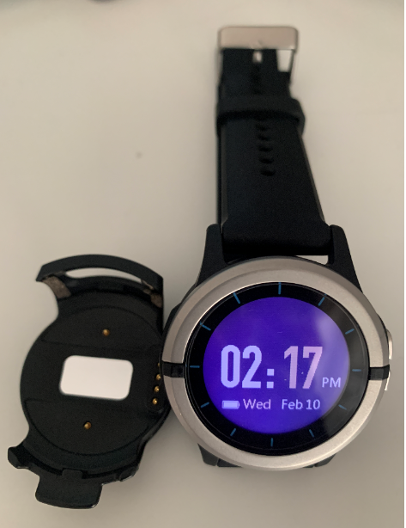

Figure 2: ADI VSM Study Watch with charging cradle

## Watch Connections

### Boot mode Buttons

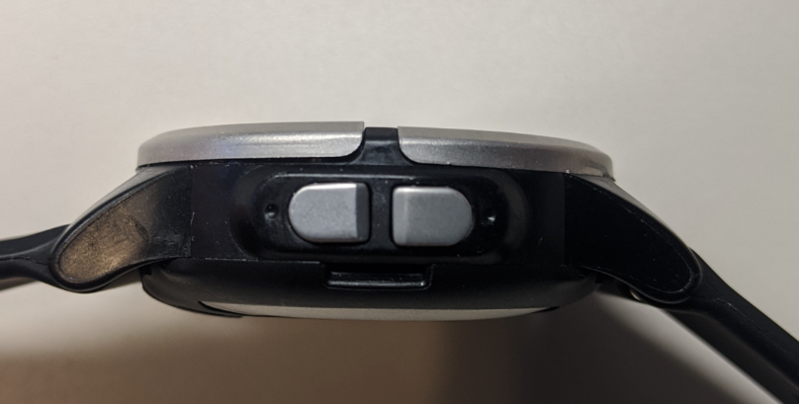

***Action***

***Navigate***

Figure 3: Navigate and Action Buttons

### USB Connections

There are two micro USB ports in the cradle.

* Data micro USB port for charging and connecting to the Wavetool
* External electrode micro USB port for connecting to the external electrode

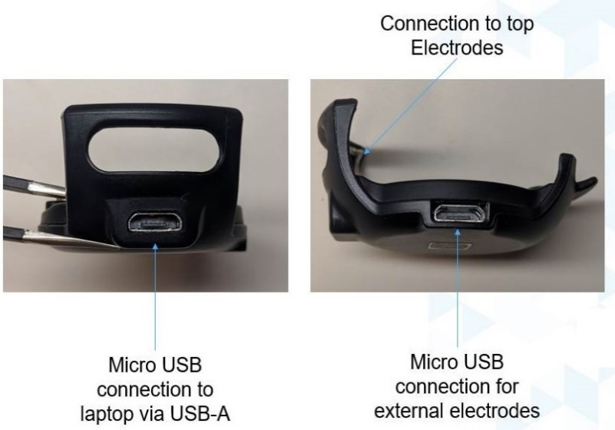

Figure 4: USB Connection

### Nordic BLE Dongle Setup

To connect the watch in the Wavetool software using BLE, the user may need to program the [nRF52840 Dongle](https://www.nordicsemi.com/Software-and-tools/Development-Kits/nRF52840-Dongle/Download#infotabs). Please follow the steps below to program the BLE dongle to be discovered as a COM port in Wavetool.

1. Install nRfConnect from the given link -   
   <https://www.nordicsemi.com/Software-and-tools/Development-Tools/nRF-Connect-for-desktop> - Download the latest version for Windows.
2. Install the Programmer and open the Programmer

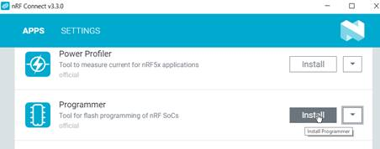

Figure 5: nRF Connect App

1. Plug in the BLE dongle and put the device in Boot mode by pressing the black button as shown in the figure. A LED will start blinking red.

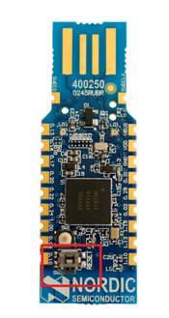

Figure 6: Nordic BLE Dongle

1. Select the dongle via the nRF Connect Programmer

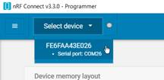

Figure 7: Connecting the BLE Dongle in Boot mode

1. Add HEX file from the path – <*WAVETOOL_INSTALL_FOLDER*> \etc\BLEDongle\ADIBLEDongle_S140.hex
2. Write the firmware to the dongle. The messages as shown in the figure below will indicate the completion of the firmware update.

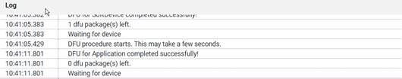

Figure 8: Firmware Update Completion

1. Unplug and re-plug the dongle.

# Quick Start Guide

The below sections will detail the steps involved in connecting the watch to WaveTool and successfully running VSM applications.

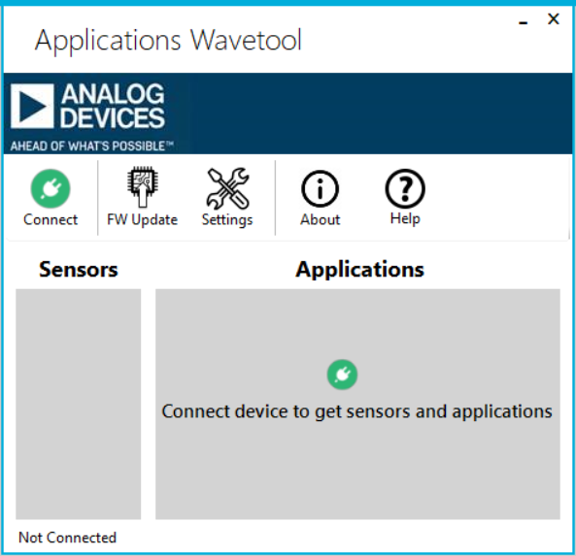

Figure 9: Wavetool Software Main Window

## Updating Firmware

If this is your first time using the watch, then please update the firmware. Otherwise you can skip this section and proceed to connecting with the Watch.

Please follow the steps below to update the firmware for the watch.

* Please remove all the USB Serial Devices and the BLE Dongle since Wavetool automatically selects the first device COM port for updating the firmware
* Attach the watch to the charging cradle
* Connect the watch to the PC through USB
* Open Wavetool Software
* Click on the FW Update
* Select ‘*Perseus*’
* Hold down both the ‘*Navigation’* and ‘*Action’* buttons for 5 seconds and confirm the bootloader icon in display
* Click on ‘*Continue’* to finish the Firmware update

Note: In case after hitting continue, wavetool selects incorrect com port to upload the firmware, remove the dongle connected to your computer and try again.

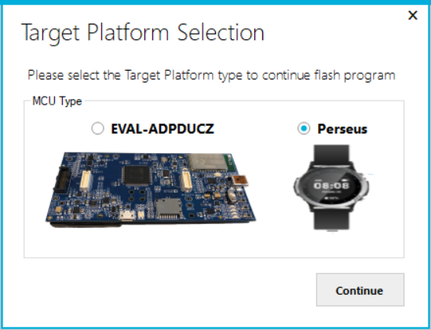

Figure 10 : Firmware Update Window in Wavetool

## Connecting to the Watch

### Connecting using USB (Cradle)

* Attach the watch to the charging cradle
* Connect the watch to the PC through via USB(Recommended not to use USB hub)
* Open Wavetool Software
* Click on Connect 🡺 Cable
* Select the appropriate COM port of the watch and connect. You can refer the device manager to find the watch COM port

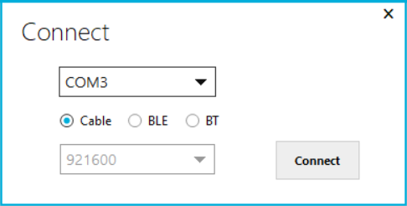

Figure 11: USB Cable connection to the Watch

* On successful connection, the following message will be displayed, after that WT will display the supported applications

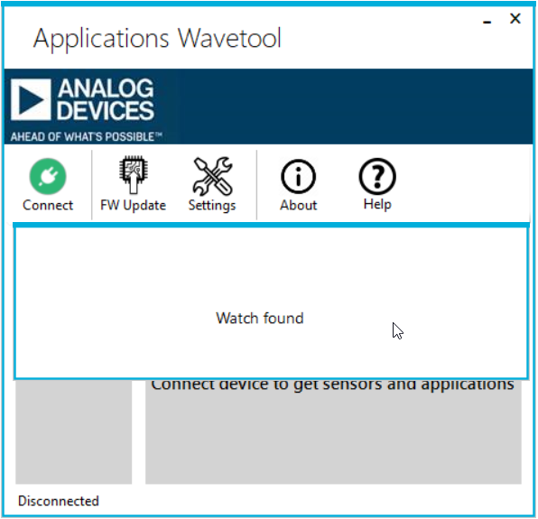

Figure 12 : Device Connected

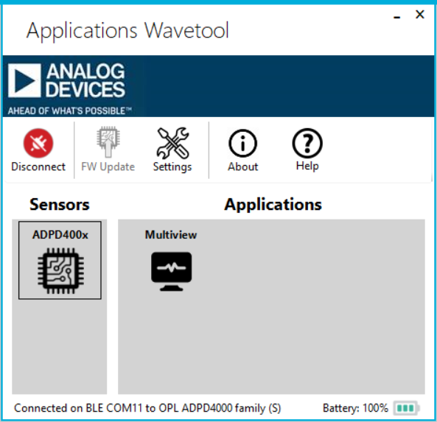

Figure 13 : Application Selection

### Connecting using BLE

* Connect the BLE dongle to the PC
* Update the BLE firmware as explained in Section 2.1.3 (If needed)
* Open Wavetool Software
* Click *Connect* 🡺 *BLE*
* Select the appropriate COM port and click on ‘*Scan’*

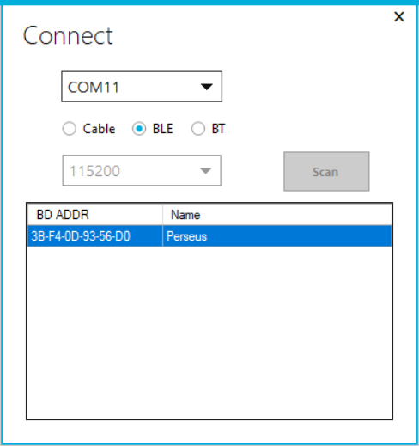

Figure 14 : BLE Connection

* Select the BLE device from the list shown and double click to connect. MAC ID of the watch could be read from Settings- > MAC id sub page. On plugging in dongle to WT & scanning, MAC ID of the watch could be checked against the scan list shown in WT.
* On successful connection “Watch Found” message will be displayed, after that WT displays the supported applications.

## Basic Wavetool View Controls

|  |  |
| --- | --- |
| Basic View Controls |  |
|  | Stop mode |
|  | Play mode |
|  | Pause mode |
|  | Open config settings |
|  | UDP Enable |
|  | Nandflash logging |
|  | Logs the data in the local machine |
|  | DCB Access |
|  | Low Touch Settings |

The controls of the view are as explained below:

1. **Play**: Start streaming data from the sensors
2. **Stop**: Stop streaming data from the sensors and clear the plots
3. **Pause**: Pause the streaming and show the current data on the plots
4. **Settings**: Opens the configuration settings to set the configuration for the use case.
5. **UDP**: Send the graph data through the UDP
6. **Nandflash logging**: Logs the selected data streams into the NAND Flash
7. **Log**: Save the data from the sensors into a JSON and CSV file in local PC
8. **DCB (Device Configuration Block) Access**: The nRF52840 MCU has a NOR flash which enables user to save and load the config in the local flash. This utility will enable users to write, read, erase the config in the NOR flash
9. **Low Touch (LT) Logging**: This allows user to configure the LT configuration via nandflash and DCB. LT config and tuning view is explained separately in the upcoming sections
10. **Filter**: This allows user to set an appropriate filter for the raw PPG data stream.
    1. **Type**: The filter type is to choose the type of the filter like BandPass (BP), Moving Average or Low Pass and is limited to a set of filters defined in the ‘*<WAVETOOL_INSTALL_FOLDER >\etc\FilterConfig\FilterType.json’* file.

**Tap Count**: The number of taps for the filter type chosen

1. **AGC (Automatic Gain Control):** This option is to enable or disable the AGC for the LED which is selected in the slot selection
2. **SQI (Signal Quality Index):** The SQI feature is supported for PPG signal frequencies ranging from 25-100Hz. The SQI score is a floating-point value between 0(poor signal quality) and 1(excellent quality).

## Multiview Application

This is the application which will enable users to analyse a combination of VSM applications in a single view

### Running Use-cases for the Multiview

* Open Wavetool
* Update the firmware for the watch (If needed)
* Connect using BLE or USB
* Open Multiview under the Applications box.
* Select the necessary use case to be analysed
* Configure their settings such as Filter type, Slot selection, AGC Enable, etc.
* Press ‘*Play*’ to analyse the data streams

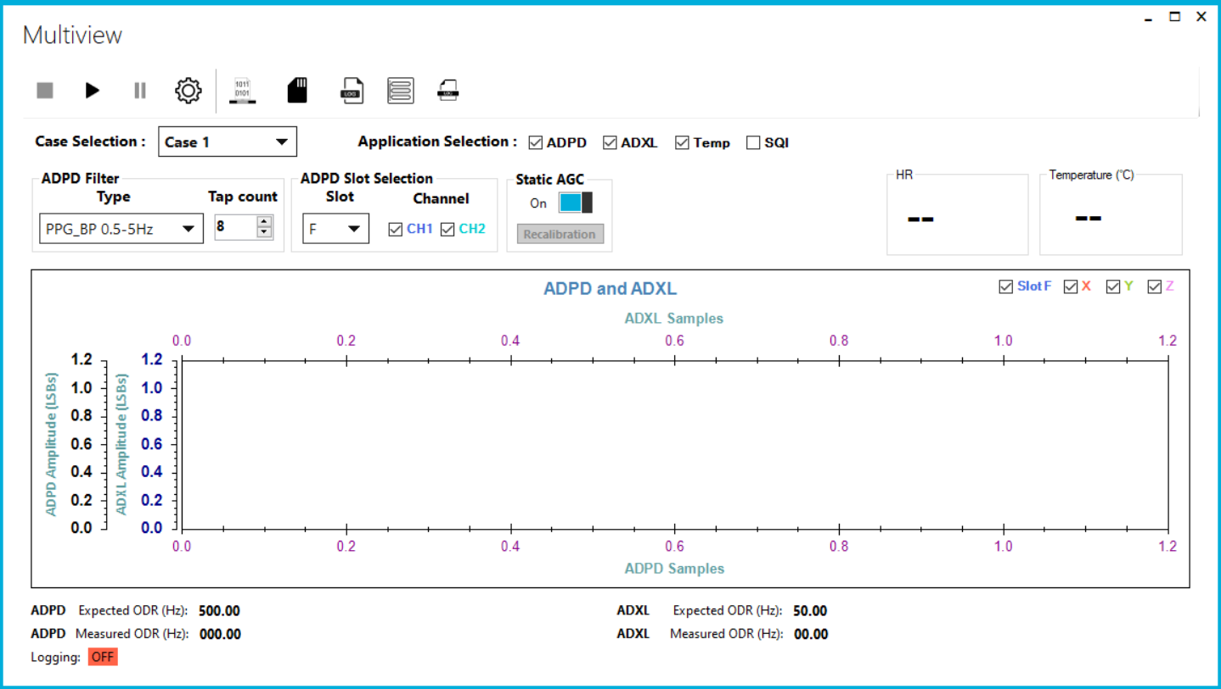

Figure 15 : Multiview

Note: Deselecting the applications from application selection window before starting stream will remove the graph for that sensor and make more room for the sensor of interest

### Multiview Usecases

#### Usecase1 - ADPD High Performance

Usecase1 used to analyse the ADPD at high data rate. The default settings are ADPD – 500Hz, ADXL – 50Hz and Temperature – 1Hz

Figure 16: Multiview ADPD + ADXL

#### Usecase2 - ADPD + EDA

Usecase2 used to analyse the EDA along with the ADPD application. The default settings are ADPD – 100Hz, ADXL – 50Hz, EDA – 30HZ ODR, 100Hz Excitation Frequency and Temperature – 1Hz

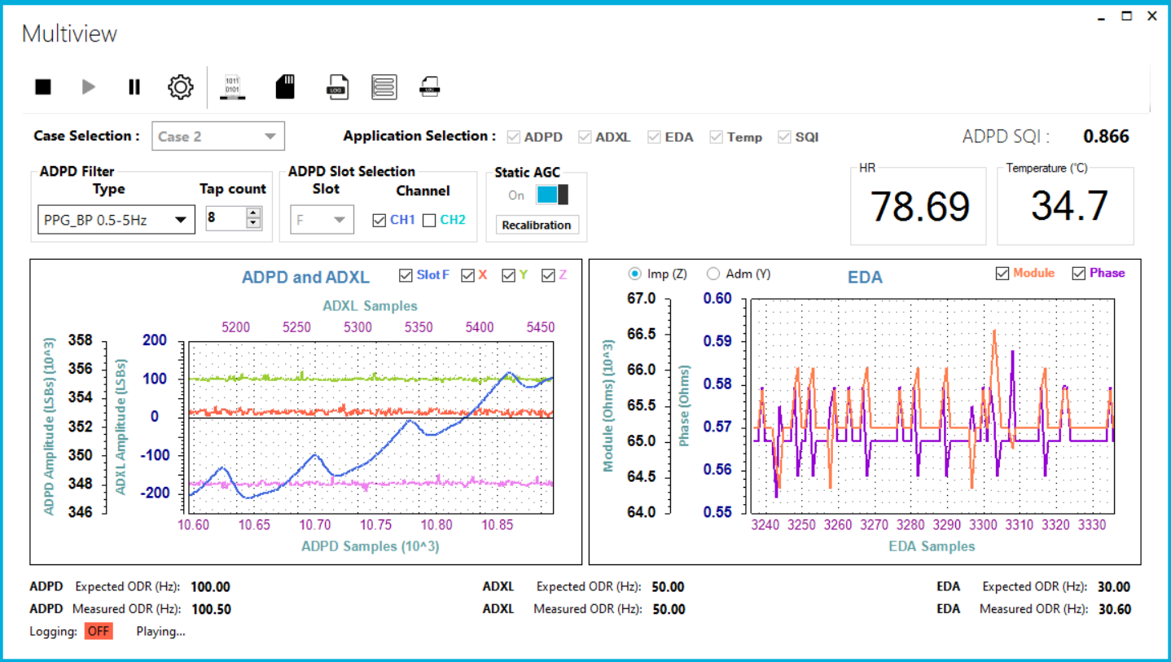

Figure 17 : Multiview ADPD + EDA

#### Usecase3 - ADPD + ECG

Usecase3 used to analyse the ECG along with the ADPD application. The default settings are ADPD – 100Hz, ADXL – 50Hz, ECG – 250HZ and Temperature – 1Hz

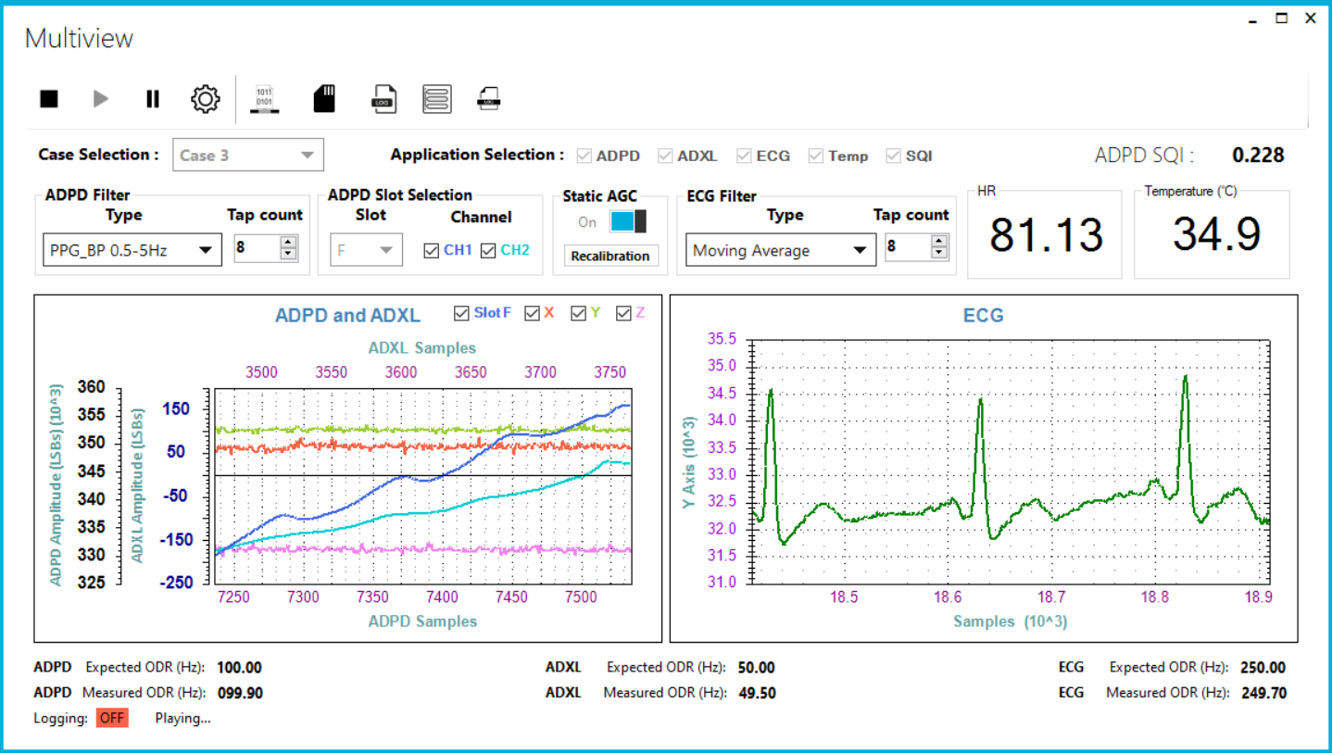

Figure 18 : Multiview ADPD + ECG

#### Usecase4 - PPG + ECG (High Performance)

Usecase4 used to analyse the PPG and ECG. The default settings are PPG – 50Hz, ECG – 1000HZ and Temperature – 1Hz

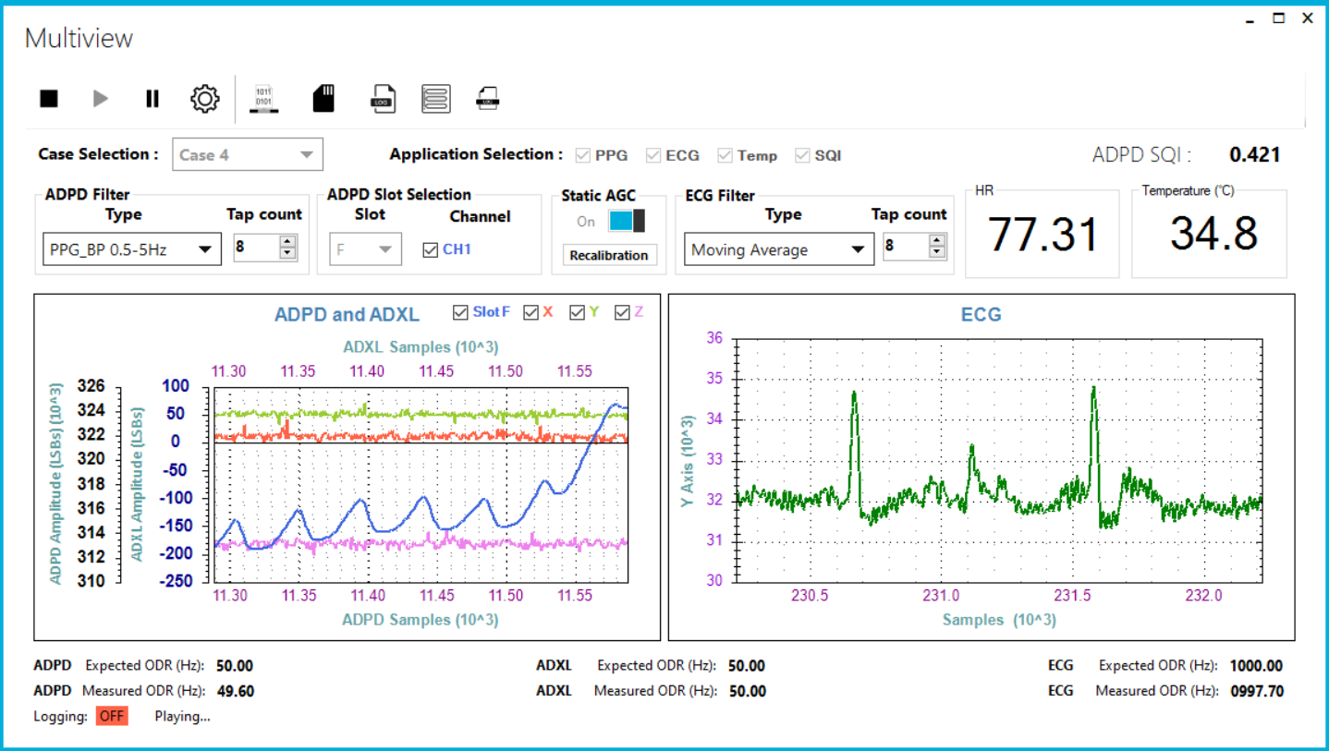

Figure 19 : Multiview PPG + ECG

#### Usecase5 - ADPD Multislot

Usecase5 used to analyse ADPD with multi slot settings and their AGC. The default settings are ADPD – 100Hz and ADXL – 50Hz

The slots selection and AGC settings can be changed in the slot selection window

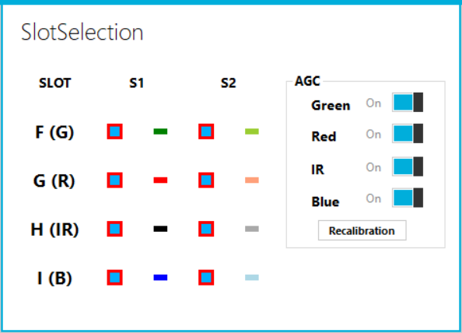

Figure 20 : Slot selection

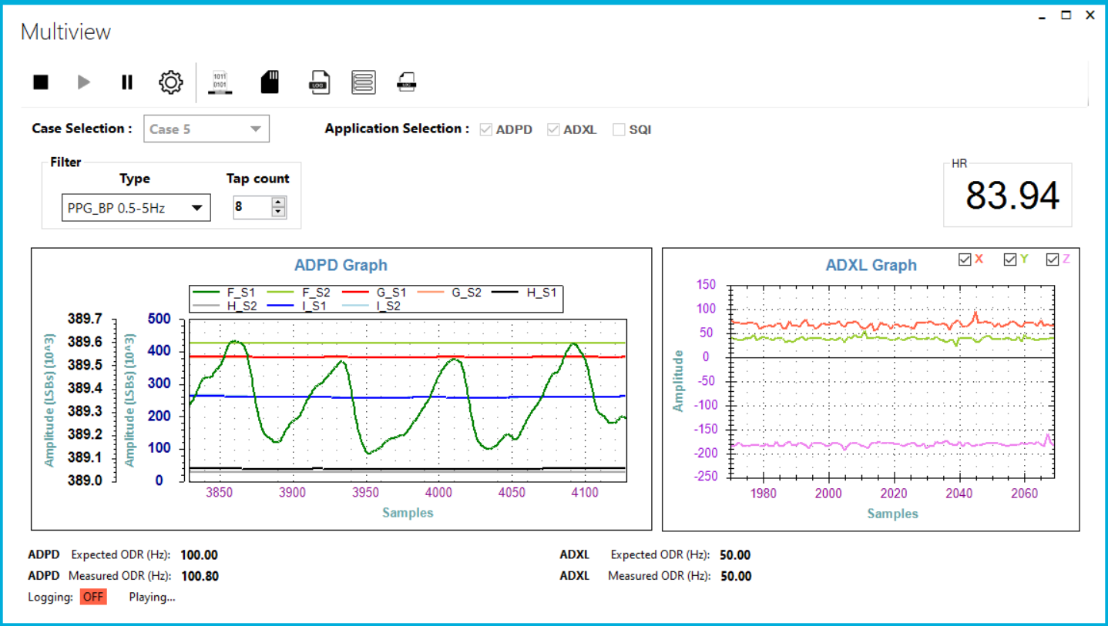

Figure 21 : Multiview ADPD multislot

### Configuring Use-cases for the Multiview

The Multiview will allow users to run a combination of VSM apps as defined in the ‘‘*<WAVETOOL_INSTALL_FOLDER >\etc\MultiviewProperty.json*’

It’s advisable to use the use case with the default views supported and it depends on the applications to be analysed.

To modify the existing use case

1. Modify the JSON entry with
   1. “*Freq*”: Sampling rate for each of these applications

These are the use cases supported in the Multiview and its default frequency values. These values will be loaded when we are switching between the use cases.

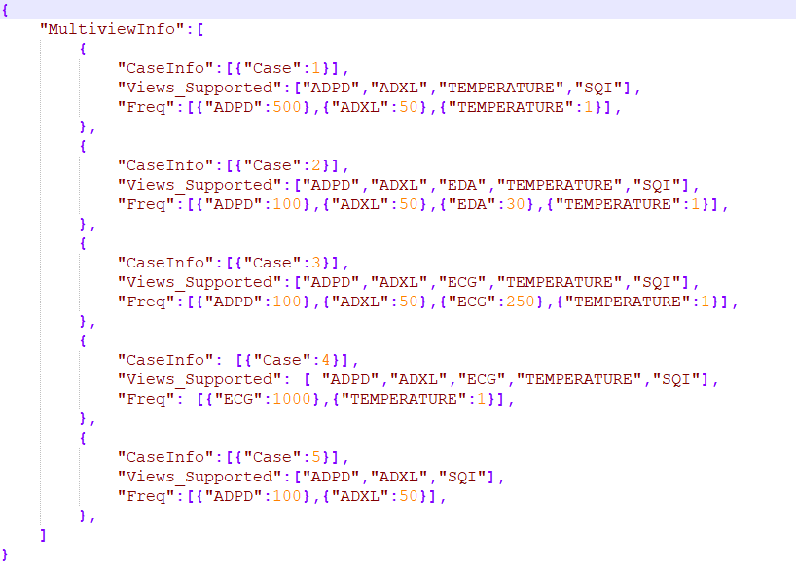

Figure 22: Multiview Use-case Definition File

### Multiview Controls

#### DCB Access

This utility will enable users to write, read, erase the config in the NOR flash

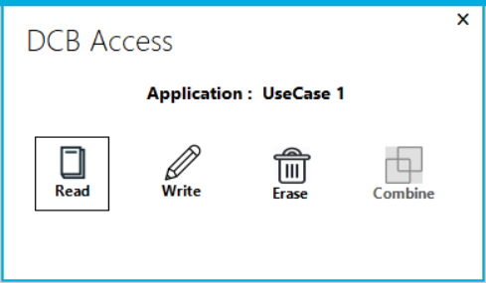

Figure 23 : DCB Access

*Read*: Read DCB config from NOR flash

*Write*: Write DCB to config into NOR flash (existing DCFG)

*Erase*: Erase DCB contents in the NOR flash

Once a DCB is written, it will be persistent between watch resets, until it is explicitly deleted. The application would work with DCB configuration, if available (default firmware configuration is overridden).

If the particular use case DCB is written to the NOR flash, then the application works with the configuration irrespective of the use case. Write the corresponding DCB configuration for the corresponding use case.

Alert messages for DCB present based on the applications supported by the particular use case are provided as below and it is represented in the application selection also.

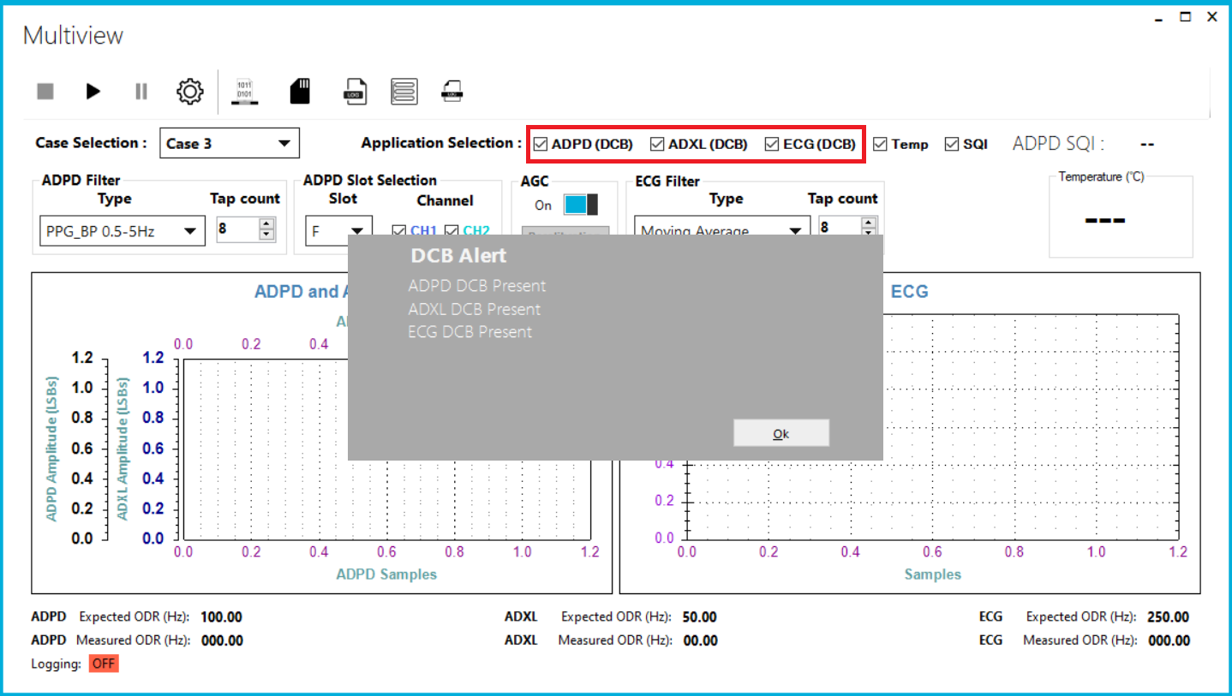

Figure 24 : DCB in Multiview

#### Low Touch Configuration

Low touch (LT) allows for a few unique features when using the watch. It allows the watch to be preconfigured to automatically log specific data streams if the watch is on the user’s wrist (based on a capacitance measurement) – when it is off the wrist, the device will stop logging and then go to a lower power state. This mode is used to start/stop logging without the use of button/tool

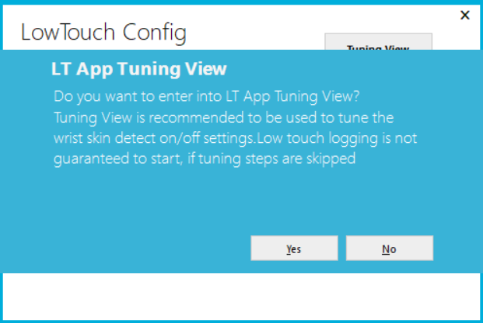

Figure 25 : Low Touch Tuning Selection

When the Low Touch Configuration is clicked the above alert message is displayed to enter into the Low Touch Tuning window in order to tune the wrist detect on/off for the low touch application.

The wrist detection is based on capacitance change that is detected by the touch sensor, at the bottom part of watch. There would a change in capacitance, when watch is placed on wrist from where it was kept initially – another surface like air or a table. This difference in capacitance is not a fixed value and varies between person to person and even from one watch to another. To improve the accuracy for wrist detection and thus to improve the LT application, the latter works with a default firmware lcfg, which is reconfigurable. LowTouch tuning window of WT serves this purpose.

By clicking “Yes” it will direct to the LowTouch tuning window as below

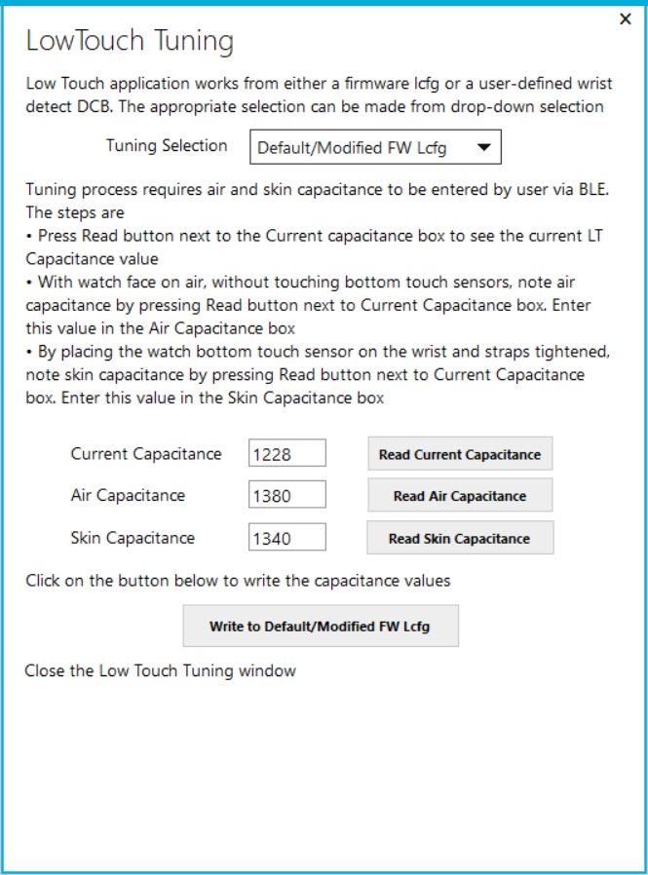

Figure 26 : Low Touch Tuning FW Lcfg

Follow the steps to write the capacitance values to the Default/Modified FW Lcfg.

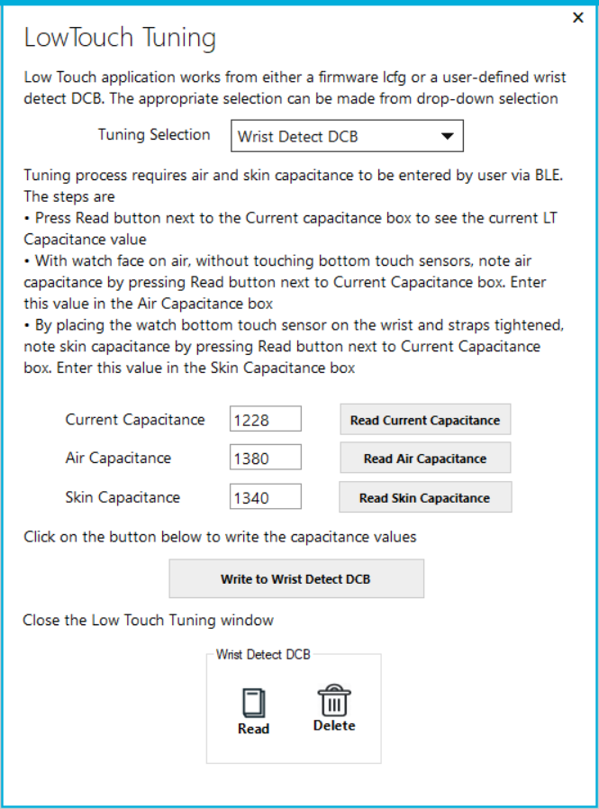

Figure 27 : Low Touch Tuning Wrist detect DCB

For wrist detect DCB, we have options to read and delete the wrist detect capacitance values which is already written in the DCB.

If the wrist detect DCB is already present when the LT view is opened, then the warning will be shown as “WRIST_DETECT_DCB is present”.

After the tuning is done, LowTouch Config window is displayed as below

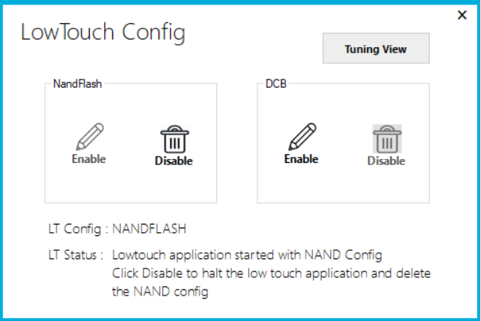

Figure 28 : Low Touch Config

LowTouch Config window is to be used to write the LT configuration file – either the DCB file or the NAND config file onto the watch by clicking the Enable button. The corresponding message will be displayed as below

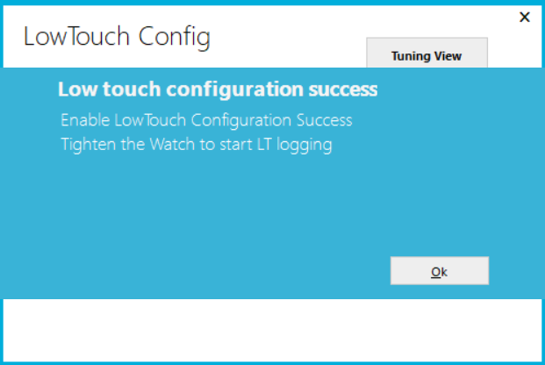

Figure 29 : Low Touch Config Success

Deletion of the config file is also done using the Disable button, if LT logging is not started.

After writing the config file to the watch, the LT application gets launched and it starts/stops logging depending on the wrist ON/OFF. The corresponding messages will be displayed in the AWT.

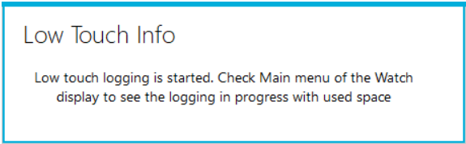

Figure 30 : Low touch started

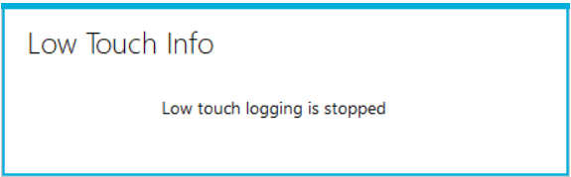

Figure 31 : Low touch stopped

Once LT config file is written into the Watch from LT Logging View of the Multiview, the user can disconnect from the WT, to do further tests. On connecting a Watch to AWT, it detects if LT application is active. User should accept to switch Watch to normal mode to continue using the AWT. The LT config files (both DCB and nandflash) get deleted when the Watch switches to the normal mode.

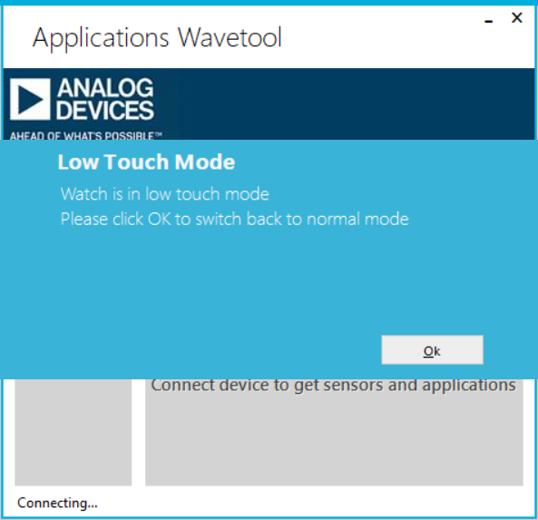

Figure 32 : Low touch mode

Switching to normal mode from LT mode fails, if LT logging is in progress. Watch needs to be taken off the wrist, to stop LT logging. If even after removing the Watch, LT logging continues, (this can happen if LT tuning is not proper), then user can disable LT app from the Watch display. From LOW_TOUCH_LOGGING page in Watch display and within that the LT APP sub-page, press action button to disable the LT Application. After this connect Watch to AWT and accept to switch to Normal mode. If wrist detect DCB is present,then user will be asked whether to delete this DCB or not.

After switching back to the normal mode, the below message will appear and the connection will be established

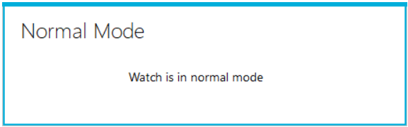

Figure 33 : Watch normal mode

### Configuring Settings for the Applications in Multiview

The configuration of settings will be based on the use-case selected. A separate config for ADPD, ADXL, ECG, etc will be provided as shown in the figure below. Users can

* *Load* a saved config file
* *Save* the current config in a new file
* *Apply* the modified config to the system

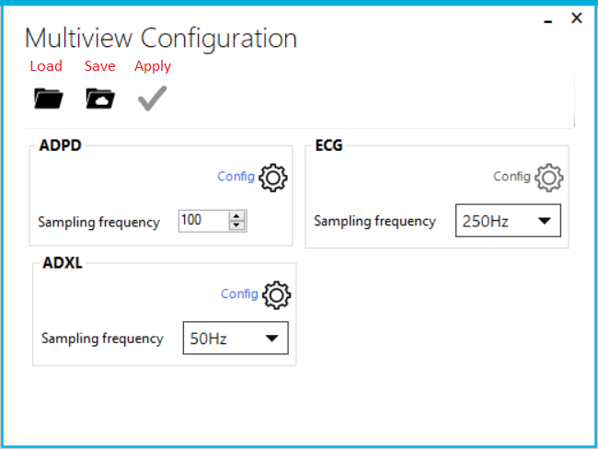

Figure 34: Multi-view Configuration

## AWT Extension Modules

Wavetool allows user to transfer graph data (applications selected in the use case) via UDP to an external application for post processing.

|  |  |
| --- | --- |
| Graph Data Sources | |
| ADPD4100 | 0xA1 |
| ADXL | 0xB0 |
| PPG | 0xC0 |
| Reserved | 0xC1 |
| ECG | 0xC2 |
| EDA | 0xC3 |
| TEMP | 0xC4 |

**ADPD:**

|  |  |  |  |  |  |  |  |  |
| --- | --- | --- | --- | --- | --- | --- | --- | --- |
| 0 | 1-2 | 3-4 | 5-8 | 9-20 | 21 | 22-23 | 24 -… |  |
| Source | Length | Seq No | Timestamp | Slot  Info | Int Status Flag | Reserved | Data (double – 8bytes each) | Interrupt Status |

|  |  |
| --- | --- |
| Source | 0xA1 – ADPD4x00 data packets |
| Length | Total UDP Packet Length |
| Seq No | Sequence number for packet count from 0 to 0xFFFF, rolls over |
| Timestamp | Current time in milliseconds |
| Slot Info | *Slot Info*  [0] - D1: 1- enabled, 0 -disabled  [1] - D2: 1- enabled, 0 -disabled  [2] - S1: 1- enabled, 0 -disabled  [3] - S2: 1- enabled, 0 -disabled  [4] - L1: 1- enabled, 0 -disabled  [5] - L2: 1- enabled, 0 -disabled |
| Interrupt Status Flag | *Interrupt Status Flag*  [4]  0 - Interrupt Data Not available  1 - Interrupt Data Available |
| Data | All data is in 8-byte doubles format. Dependent on Slot Info.  The double type complies with the IEC 60559:1989 (IEEE 754) standard for binary floating-point arithmetic.  See: [DoubleDataFormat](https://docs.microsoft.com/en-us/dotnet/api/system.bitconverter.getbytes?view=netframework-4.7.2%23System_BitConverter_GetBytes_System_Double_) |
| Interrupt Status data | All Interrupt data is in 8-byte doubles format. Where the double type complies with the IEC 60559:1989 (IEEE 754) standard for binary floating-point arithmetic. |

**ADXL:**

|  |  |  |  |  |  |  |
| --- | --- | --- | --- | --- | --- | --- |
| 0 | 1-2 | 3-4 | 5 | 6-8 | 9-10 | 11 -… |
| Source | Length | Seq No | No of Sample | Reserved (Header Info) | Reserved  (Info) | Data (double – 8bytes each) |

|  |  |
| --- | --- |
| Source | 0xB0 – ADXL data packets |
| Length | Total UDP Packet Length |
| Seq No | Sequence number for packet count from 0 to 0xFFFF, rolls over |
| No of Sample | Number of samples in the packet |
| Data  (Timestamp& Data) | All data is in 8-byte doubles format. Dependent on Slot Info.  The double type complies with the IEC 60559:1989 (IEEE 754) standard for binary floating-point arithmetic.  See: [DoubleDataFormat](https://docs.microsoft.com/en-us/dotnet/api/system.bitconverter.getbytes?view=netframework-4.7.2%23System_BitConverter_GetBytes_System_Double_)  Data format : [TS, X, Y, Z] |

**PPG:**

|  |  |  |  |  |  |  |
| --- | --- | --- | --- | --- | --- | --- |
| 0 | 1-2 | 3-4 | 5 | 6-8 | 9-10 | 11 -… |
| Source | Length | Seq No | No of Sample | Reserved (Header Info) | Reserved  (Info) | Data (double – 8bytes each) |

|  |  |
| --- | --- |
| Source | 0xC0 – PPG data packets |
| Length | Total UDP Packet Length |
| Seq No | Sequence number for packet count from 0 to 0xFFFF, rolls over |
| No of Sample | Number of samples in the packet |
| Data  (Timestamp& Data) | All data is in 8-byte doubles format. Dependent on Slot Info.  The double type complies with the IEC 60559:1989 (IEEE 754) standard for binary floating-point arithmetic.  See: [DoubleDataFormat](https://docs.microsoft.com/en-us/dotnet/api/system.bitconverter.getbytes?view=netframework-4.7.2%23System_BitConverter_GetBytes_System_Double_)  Data format : [TS, ADPD, X, Y, Z, HR] |

**ECG:**

|  |  |  |  |  |  |  |  |  |  |
| --- | --- | --- | --- | --- | --- | --- | --- | --- | --- |
| 0 | 1-2 | 3-4 | 5 | 6-8 | 9 | 10 | 11 | 12-13 | 11 -… |
| Source | Length | Seq No | No of Sample | Reserved (Header Info) | Sensor Type | Algo/  Electrode  Type | Lead  Status | Reserved | Data (double – 8bytes each) |

|  |  |
| --- | --- |
| Source | 0xC2 – ECG data packets |
| Length | Total UDP Packet Length |
| Seq No | Sequence number for packet count from 0 to 0xFFFF, rolls over |
| No of Sample | Number of samples in the packet |
| Sensor Type | Sensor Info [3:0]  0 - AD7689  1 - AD5940  2 - AD4000  3 - None  Reserved [7:4] |
| Algo/Electrode Type | Algo Info [3:0]  0 - None  1 - Sport  2 - Monitor  Electrode Info [7:4]  0 - None  1 - Case/Watch  2 - Lateral/External |
| Lead Status | Lead Info [1:0]  0 - OFF  1 - ON |
| Data  (Timestamp& Data) | All data is in 8-byte doubles format. Dependent on Slot Info.  The double type complies with the IEC 60559:1989 (IEEE 754) standard for binary floating-point arithmetic.  See: [DoubleDataFormat](https://docs.microsoft.com/en-us/dotnet/api/system.bitconverter.getbytes?view=netframework-4.7.2%23System_BitConverter_GetBytes_System_Double_)  Data format : [TS, ECG, HR] |

**TEMPERATURE:**

|  |  |  |  |  |  |  |
| --- | --- | --- | --- | --- | --- | --- |
| 0 | 1-2 | 3-4 | 5 | 6-8 | 9-10 | 11 -… |
| Source | Length | Seq No | No of Sample | Reserved (Header Info) | Reserved  (Info) | Data (double – 8bytes each) |

|  |  |
| --- | --- |
| Source | 0xC4 – Temperature data packets |
| Length | Total UDP Packet Length |
| Seq No | Sequence number for packet count from 0 to 0xFFFF, rolls over |
| No of Sample | Number of samples in the packet |
| Data  (Timestamp& Data) | All data is in 8-byte doubles format. Dependent on Slot Info.  The double type complies with the IEC 60559:1989 (IEEE 754) standard for binary floating-point arithmetic.  See: [DoubleDataFormat](https://docs.microsoft.com/en-us/dotnet/api/system.bitconverter.getbytes?view=netframework-4.7.2%23System_BitConverter_GetBytes_System_Double_)  Data format : [TS, Temp1, Temp2] |

**EDA:**

|  |  |  |  |  |  |  |
| --- | --- | --- | --- | --- | --- | --- |
| 0 | 1-2 | 3-4 | 5 | 6-8 | 9-10 | 11 -… |
| Source | Length | Seq No | No of Sample | Reserved (Header Info) | Reserved  (Info) | Data (double – 8bytes each) |

|  |  |
| --- | --- |
| Source | 0xC3 – EDA data packets |
| Length | Total UDP Packet Length |
| Seq No | Sequence number for packet count from 0 to 0xFFFF, rolls over |
| No of Sample | Number of samples in the packet |
| Impedance /Admittance | Sensor Info [3:0]  0 - Impedance  1 - Admittance |
| Data  (Timestamp& Data) | All data is in 8-byte doubles format. Dependent on Slot Info.  The double type complies with the IEC 60559:1989 (IEEE 754) standard for binary floating-point arithmetic.  See: [DoubleDataFormat](https://docs.microsoft.com/en-us/dotnet/api/system.bitconverter.getbytes?view=netframework-4.7.2%23System_BitConverter_GetBytes_System_Double_)  Data format: [TS, Module, Phase] |

The Graph data is packetized and sent via the port settings as specified in the Settings window.

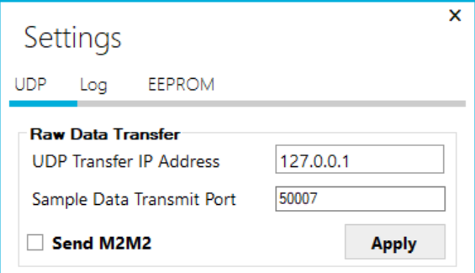

Figure 35: UDP Settings for Data Transfer

In the Multiview the UDP transfer is enabled as shown in figure below

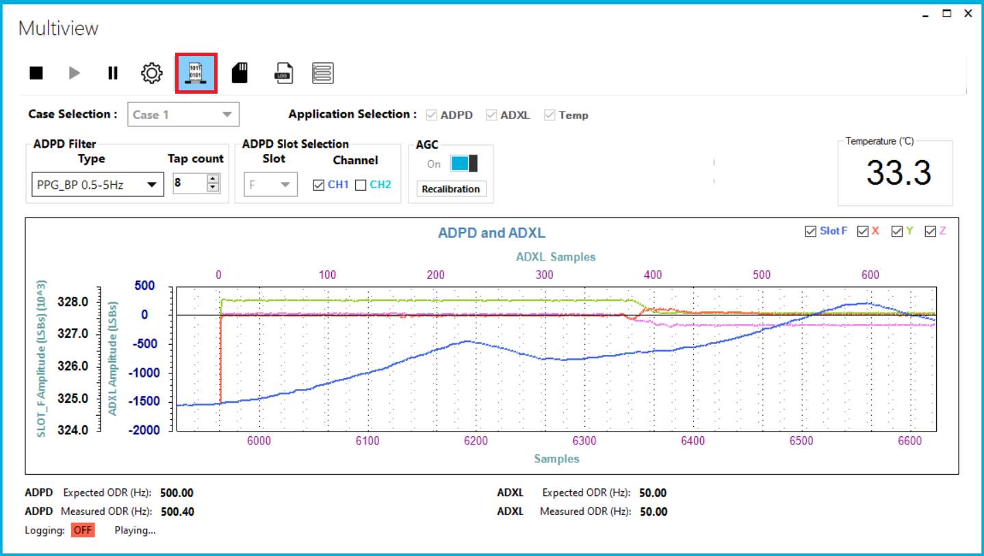

Figure 36 : Multiview UDP enable

The AWT External Modules which contains the parser to extract the data from the Wavetool to different applications such as:

* Python
* LabView
* Matlab

These parser modules and examples to get the data out from Wavetool can be found in

<https://github.com/analogdevicesinc/ApplicationsWaveTool>.

## Logging Data in Local Files

Raw data can be logged in local files which are stored in JSON or CSV file format.



Figure 37 : Open Log

After the log stops, the “Click to open log” hyperlink is shown in the bottom of the view. Clicking the hyperlink opens the location where the logs are stored.

The log folder can be opened from the open logs folder in settings window logging tab

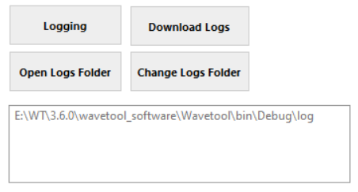

Figure 38 : Logging Settings

The log folder contains the m2m2, JSON and CSV files

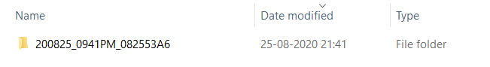

Figure 39 : Log Folder

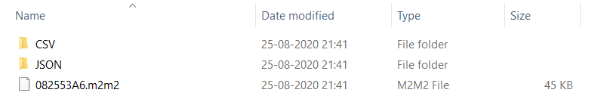

Figure 40 : Log Files

The m2m2 file is the log file that was retrieved from the device

The CSV and JSON folders contain equivalent files generated from the m2m2 file

The CSV folder contains the logging data and summary

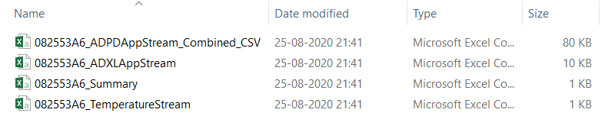

Figure 41 : CSV Folder

ADPDAppStream_Combined_CSV log file is shown below

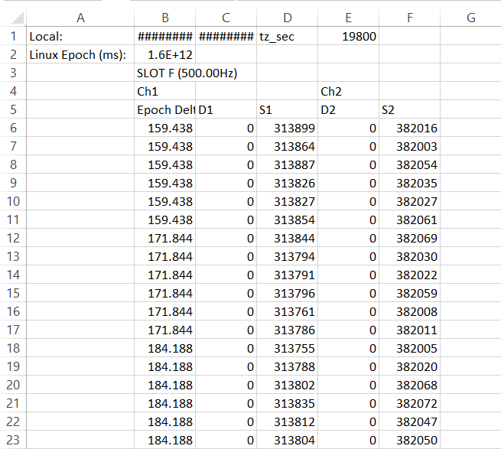

Figure 42 : CSV Data

JSON folder contains the JSON file which is converted from the m2m2 file

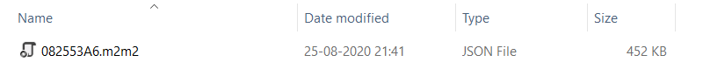

Figure 43 : JSON Folder

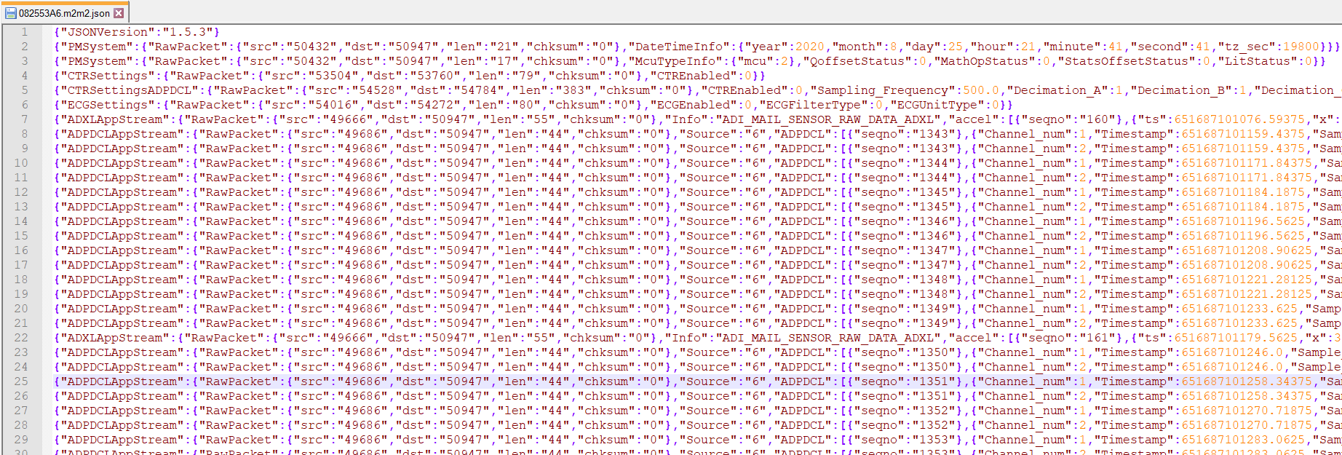

Figure 44 : JSON Data

## NAND Flash Logging

When a user wants to log data on the watch they can enable the NAND flash logging.

While the NAND flash is logging, the user can go to any other application and stream and stop the data, this doesn’t affect the NAND flash logging. NAND flash logging stops when the user disables the logging.

### Logging in NAND Flash

Logging of data into the Nand flash can be enabled from the “Settings” menu in Wavetool.

* Connect to the watch using BLE
* Open Wavetool Main window
* Open Settings 🡺 Log 🡺 Logging

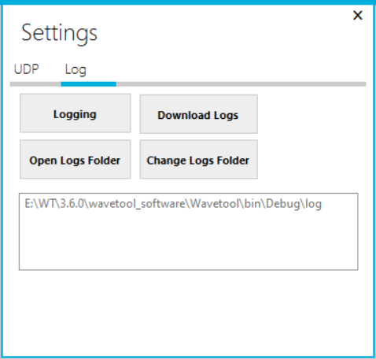

Figure 45: Logging Settings in Main window

* Select what will be logged and enter a use ID which will be stored in summary file for reference
* Turn logging on in the view.

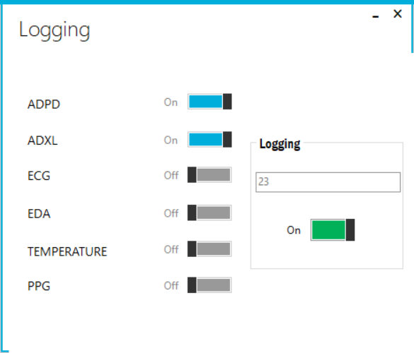

Figure 46: NAND Flash Logging Settings

### Retrieving data from NAND Flash

Assuming data is logged into the NAND flash in the watch, follow the below steps to retrieve the data from the NAND flash

* Connect the watch to the Wavetool via USB
* Open Wavetool Software Main window
* Go to Settings 🡺 Log 🡺Download Logs
* Select the relevant Log file to download
* Click on ‘*Get Log*’ to save the log to the PC
* Click on ‘Open Logs’ to open the folder where the logs are stored on the PC
* The m2m2 file is the log file that was retrieved from the firmware
* The CSV and JSON files folders contain equivalent files generated from the M2M2 file in the Wavetool.
* Click on ‘*FS Clear’* to clear the logs on the NAND Flash
* Click on ‘*FS Reset’’* to reset filesystem. Note that this will clear all logs on the NAND Flash

Figure 47: Download Log from NAND Flash

# FAQs

## What happens when a connection fails?

If the connection fails, then the following alert will be displayed

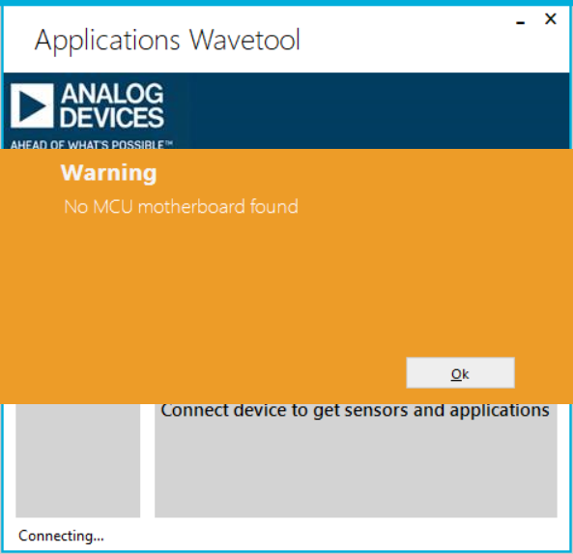

Figure 48 : Connection Failed

If BLE doesn’t respond, then the following alert will be displayed

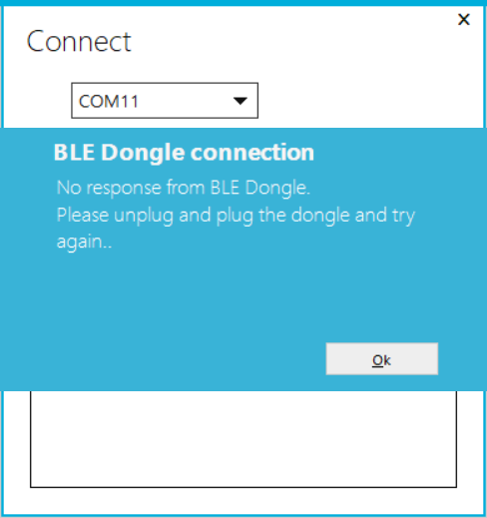

Figure 49 : BLE Connection Failure

## Can I stream data when NAND flash logging is enabled?

Yes. We can stream the data when NAND flash logging is enabled

## What are the restrictions of streaming data using BLE?

The maximum rate that can be streamed over BLE is 7.9KB/sec. Any configuration to run more than that rate will result in packet loss.

## How do I change the Filter settings in JSON file?

To change an existing filter property, edit the ‘*<WAVETOOL_INSTALL_FOLDER >\etc\FilterConfig\FilterType.json’* file.

‘*FilterName*’: Some specific name for the filter to be listed in the dropdown of the Wavetool FilterType options

‘*PassType*’: Type of filter such as MOVING_AVG, DELAY, BPF, LPF, BIQUAD. Currently these are the only filter types supported in the Wavetool.

‘*LowFrequency_3db*’: This is the Low frequency cut off of the LPF and BPF filters

‘*HighFrequency_3db*’: This is the High frequency cut off of the BPF filter

## How to flash firmware when firmware update gives the warning “Target not found”?

1. Select the watch COM port. Right click and select properties as like in the below image

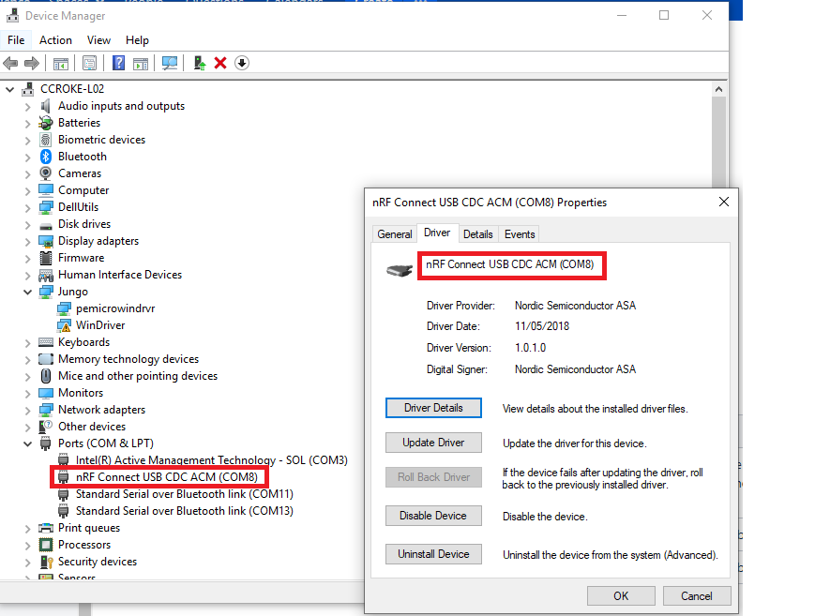

Figure 50 : Watch COM port properties

1. Select Driver and click Update Driver

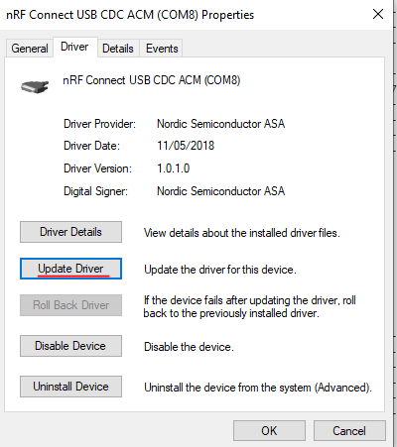

Figure 51 : Update driver

1. Select Browse my computer for driver software

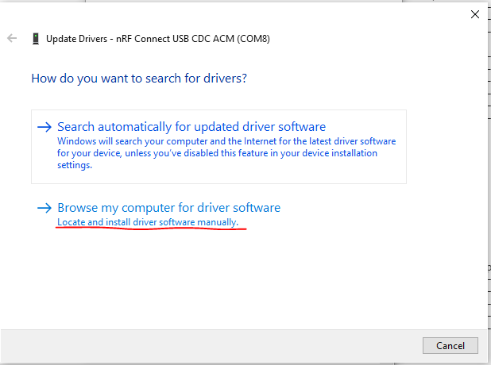

Figure 52 : Browse driver software

1. Select let me pick from a list of available drivers on my computer

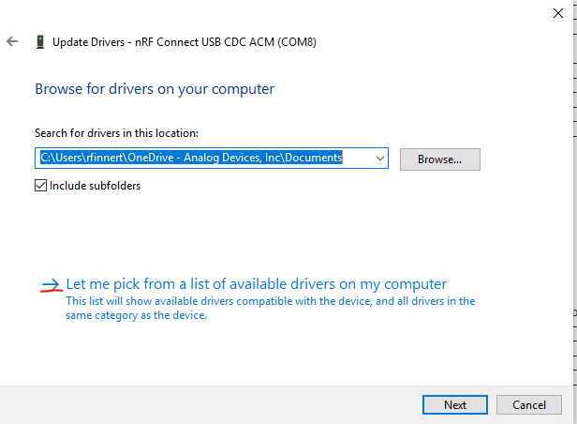

Figure 53 : Pick the available driver on computer

1. Deselect Show compatible hardware and select Nordic Semiconductor ASA, then from the Model select nRF Connect USB CDC ACM and click Next to update the driver

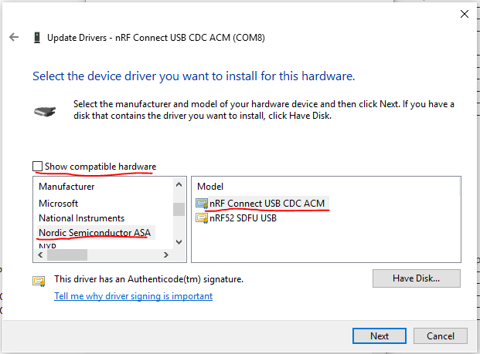

Figure 54 : Install the driver

1. Do the firmware update again

Terminology

Table 2: Terminology

|  |  |
| --- | --- |
| **Term** | **Description** |
| FW | Firmware |
| BLE | Bluetooth Low Energy |
| PPG | Photoplethysmography |
| ECG | Electrocardiography |
| SPO2 | Saturated Peripheral Oxygen |
| ODR | Output Data Rate |
| MCU | Micro Controller Unit |
| AGC | Automatic Gain Control |
| HRM | Heart Rate Measurement |
| MIPS | Million Instructions Per Second |
| LT | Low Touch Application |

References

Table 3: References

|  |  |
| --- | --- |
| **Reference No.** | **Description** |
| **[1]** | ADI_ADPD_Multimode_API_Reference.chm |
| **[2]** | Applications Wavetool |
| **[3]** | ADPD_MultiParameter_ReleaseNotes.pdf |